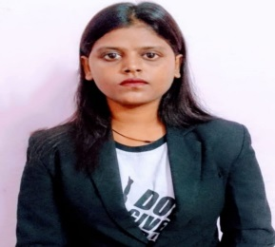

KALPANA KUMARI

3/2 GFA Line TPT near command hospital army cant
LUCKNOW UTTARPRADESH (226002)

Phone:+918922080411,+9198545039811
Email :-kalpanasingh96301@gmail.com

Carrier Objective:

To Obtain A Challenging Position That Will Fully Utilize My Skills And Talents In A Systematic Manner At The Same Time Providing Enough Opportunities For Career Growth.

Educational qualification:

Section | Institution Name | Year
HIGH SCHOOL | St Mary's day inter college | 2017
Intermediate (10+2) | St Mary's day inter college | 2019
BA | AVADH GIRLS PG COLLEGE | 2022
B.VOC(H.M) | UEI GLOBAL COLLEGE | 2022
MBA (HUMAN RESOURCES) | NMIMS COLLEGE | PERSUING

Work Experience:
- INDUSTRIAL TRAINING (215 KEY)
( 15 JUNE 2021 TO 30TH JAN 2022)

Completed Industrial Training at Clarks Amer ,Jaipur .As a Trainee, Worked here under f&b Service ,Housekeeping, and front office Departments

- Ramada Plaza by Wyndham & Ramada by Wyndham ( key -245), Lucknow : JOB TRAINING ( JULY 2022 TO DECEMBER 2022)

- Ramada Plaza by Wyndham & Ramada by Wyndham ( key -245), LucknowASSOCIATE ( PRESENT 2023)
- Work Profile ;
- Recruitments
- Employee Relation Managements
- Administrative Skill ( like Employee leave ,Absence file ,Attendance managing ,etc )
- Interview skill
- Managing Town Hall Meeting , Fun Friday activities
- Communication
- Decision – making
- Training and developments
- Leadership
- Strategic –thinking
- Multi –tasking
- Team work and collaboration
- Risk Managements

- Looking for a job in HUMAN RESOURCES DEPARTMENTS as a ASSISTANT HR

KeySkills:

- Positive Attitude.
- Self-Motivate.
- Good listener.

Language Knows:

- English & Hindi.

Personal Details:
- Name : KALPANA KUMARI
- Father’s Name :Mr.MAHENDRA PRASAD SINGH
- Nationality :Indian
- Sex : Female
- Marital status : Single
- Date of Birth : 22 /11/1998

Declaration:

I hereby declare that the above mentioned information is true to the best of my knowledge and belief
DATE: KALPANA SINGH

