**CURRICULUM VITAE**

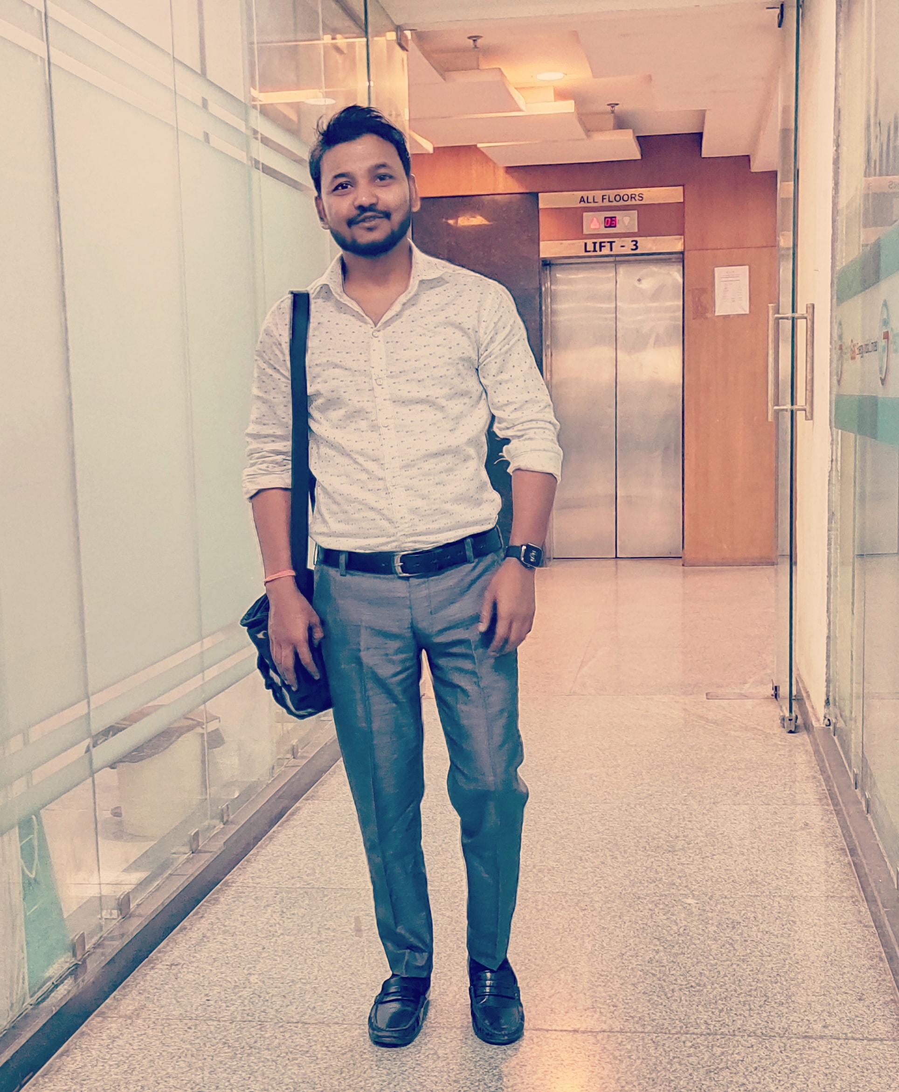

Name: Suny Dayal

Address: 485/119,Daliganj, Lucknow. Pin code – 226020

Mobile no. 8299213083 .7275301007

Mail Id: sunydayal875@gmail.com

**Career Objective:**

To continue my career in a well - reputed institute to get the best opportunities and experience.Also to contribute towards the improvement and growth of the institute by accepting challenges .

Key Skills:

* Hardworking and responsible for the completion of the task.
* Focused towards the work.
* Good Behavior management skills.
* Good communication skills.
* Ability to understand psychology.
* Learning attitude.

Academic Profile:

* LLB from Kanpur University
* B.Sc ZBC from Lucknow University in 2013.
* Intermediate from B.N.S.D.INTTER COLLEGE (UP Board) in 2009.
* High School from B.N.S.D.INTTER COLLEGE(UP Board) in 2007.

EXPERIENCE:

* 1 Year call center experience at Aegis lucknow

* 7year Teaching experience as Tutor

* Sales experience at kota life and Management

Computer Knowledge:

*Familiar with AI and Chat Gpt

*social media handling

* Basic computer knowledge of MS - office, MS - world, MS - excel and internet basics.

Extra-curricular activities:

* Participated in NSS at college level..
* Winner of Picasso Story Writing competition at college level.
* Member of science association
* organized various Nukkad Natak

Personal Profile:

Father’s name: Mr.Shyam Lal

Date of birth: 14/12/1992

Sex: male

Marital Status: Unmarried

Nationality: Indian

Linguistic capability: English, Hindi,

Hobbies: Reading, writing, listening to music,singing

Strengths

* Enthusiastic and hardworking.
* Possess positive attitude.
* Responsible towards the work.
* Self-motivated and focused.

Declaration:

I thereby declare that all the information provided above is true to my knowledge.

Date: singnature 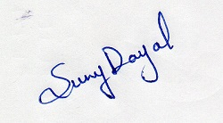

Place:Lucknow